|  |
| --- |
| 1D Motion Platform |
| Hardware Guide |

|  |
| --- |
|  |

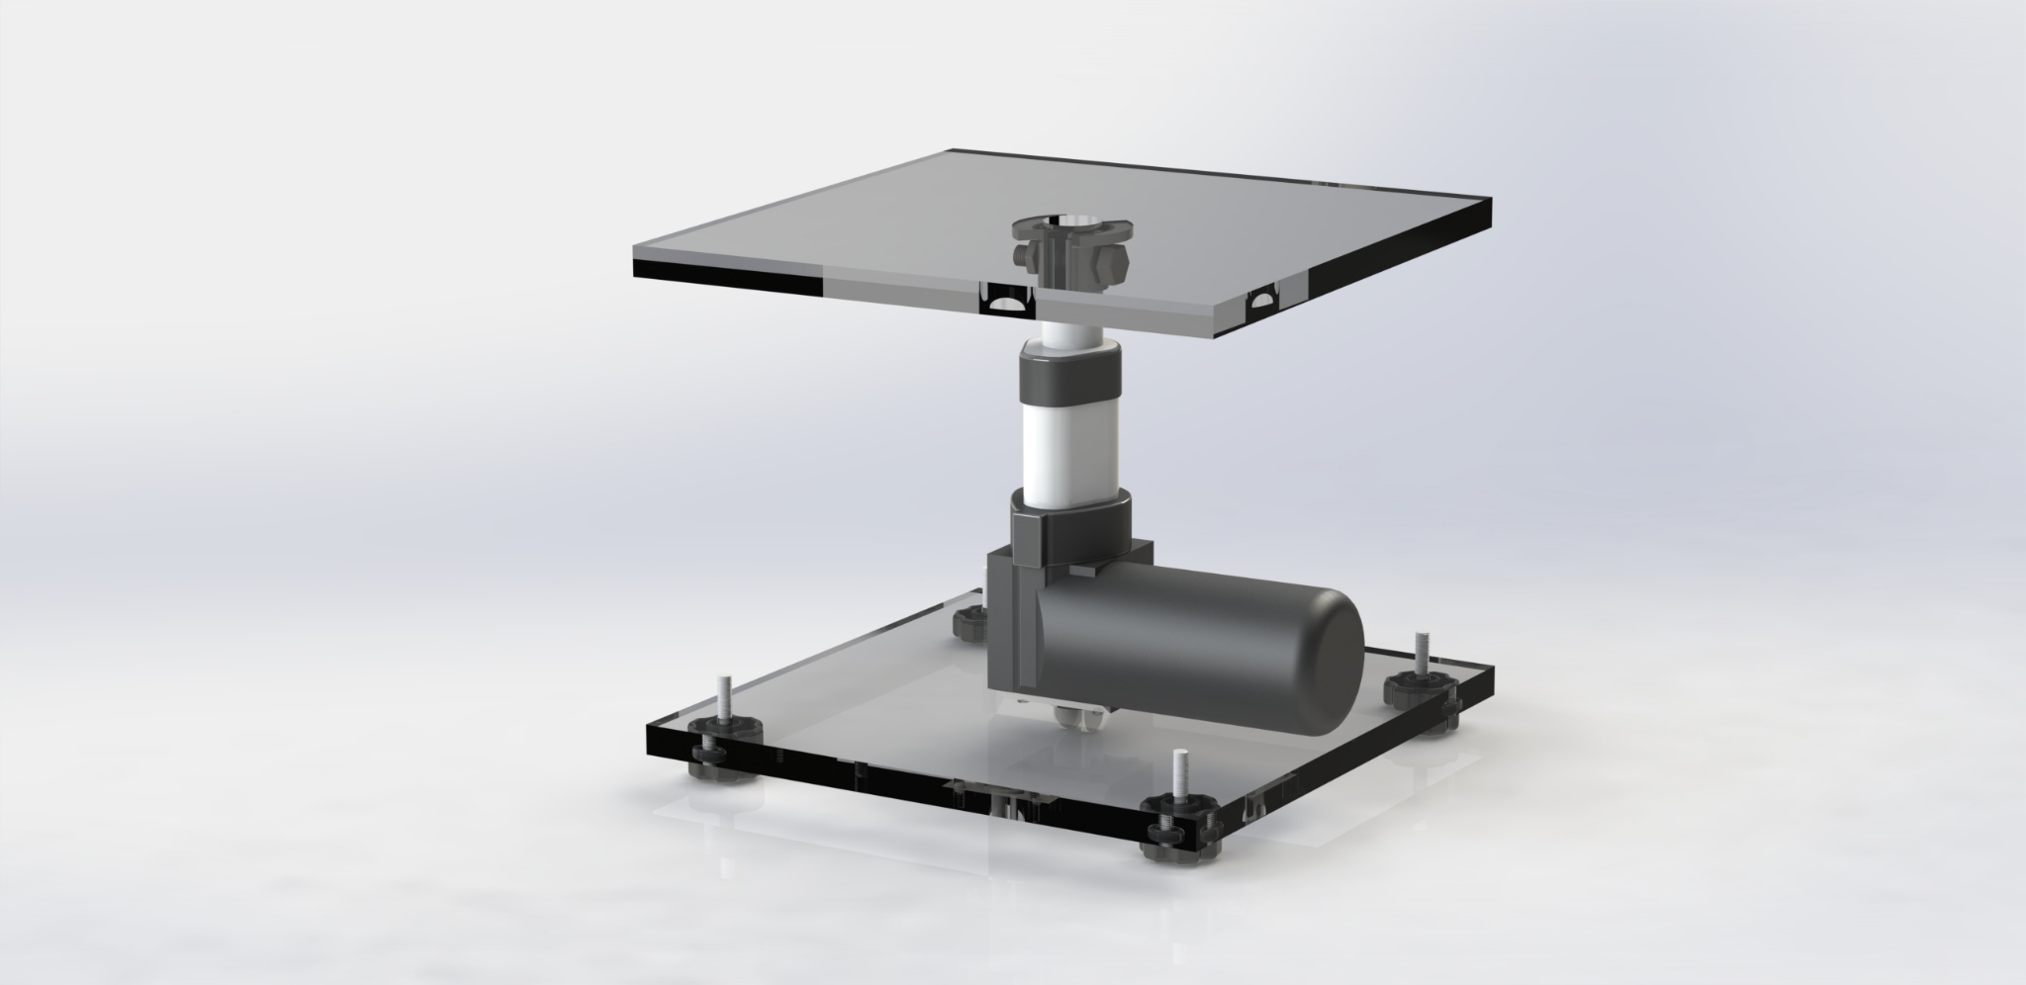

|  |
| --- |
| Hardware Guide |
| Setting up the top platform |
| The first part of setting up the 1D motion platform is to put together the top section of the platform. This is the section that attaches to the tip of the linear actuator and is the holding platform for the phantom. We needed to consider radio transparency, as well as a design that would be compatible and easily implemented/reproducible. The materials required would be a laser cut acrylic pane, with 4 holes drilled in the center, lining up with the 3D printed mount screw holes; Nylon screws (7mm) are also required to attach the custom mount to the acrylic pane.    Figure 1 - 4x Nylon screws, 3D printed mount & cut/drilled acrylic pane |

|  |
| --- |
| Hardware Guide |
|  |
| Line up the mount with the screw holes and fasten the nylon screws. Ensure a tight fit and there is no movement.  A black and white object on a wood surface  Description automatically generated  Once the top platform is put together, use M6-1.0 x 30 bolt to secure the mount onto the tip of the linear actuator. The actuator’s tip has a 6mm hole for mounting.  The custom mount and platform are now successfully put together. |
| Hardware Guide |
| Wiring up  The main components required to wire up the 1D Vertical Motion Platform are:   * High Current 43A Motor Drive Controller * 12V DC Power Supply * Optical Linear Actuator 35lbs 4in * Arduino IDE * Breadboard * Wires   Here is the wiring diagram provided by Firgelli Automations:  A diagram of a circuit board  Description automatically generated |
|  |
| |  | | --- | | Hardware Guide | | This is how the circuit should look:    Note: In this setup, we have the green wire to Arduino’s interrupt pin 2. This is to read the optical feedback signals. The final setup of the motion platform should look like this (excluding PSU).     |  | | --- | | Hardware Guide | | Additional  The .STL and .SLDPRT files of the platform mount will be available [here](https://github.com/Image-X-Institute/6-DoF-Robotic-Motion-Phantom/tree/update-7/03/2024/Documentation) for anyone to modify and reprint. Here is the engineering drawing of the mount.  A blueprint of a machine  Description automatically generated | | |